Old modernians hockey club  An account of our Women’s Teams from 1931 to 1940. | The first Old Mods women’s team took the field in 1931 and experienced immediate success!  They won the WA Women’s Hockey Association A Grade Grand Final of that year and then again in 1932 and 1934.  What follows is an account of the foundation of the team, the players and teams and an outline of their successes.  We conclude by identifying some outstanding individual member of the team.

FOUNDATION OF THE TEAM
Joseph (Joe) Parsons, Principal of Perth Modern School was a keen sponsor of sport at the school and established the Old Modernian’s Sports Council under whose banner both Men’s and Women’s hockey teams flourished.
The sport of hockey for girls was introduced in the early years at Perth Modern School and over time many fine players have been produced, some attaining both State Team and Australian Team Representation. One of these exceptional players was Jean Fitch who was largely responsible for the formation of the OMHC team in 1931 by recruiting experienced former students playing for other clubs and also recent graduates.
In its rather short history, the club won three ‘A’ Grade premierships, a remarkable achievement against long-established opposition clubs. In this period, the patronage of Joseph Parsons, the long-serving Headmaster of Perth Modern School (1923 – 1939) in support of the Old Modernians’ Association and its affiliated sporting clubs was crucial, and Jean Fitch was an active member of this group. A simple, yet significant example of his largess was permission to stage Hockey Association fixtures on the School grounds.
1931 FIRST A GRADE TEAM
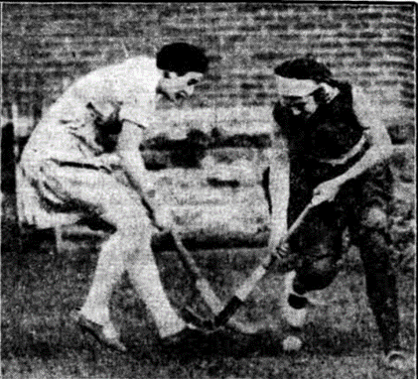
1931 FIRST FLAG
1931 Semi Final
Semi-final matches in the 'A' and 'B' Grade competitions of the. West Australian Women's A Grade- Playing North Cottesloe (minor premiers), Old Modernians soon settled down to good combination and clean open hockey and proved themselves definitely superior. Marjory Bennett was outstanding for the winners. Their first goal was secured in the second half by Jean Fitch, and their second followed a penalty bully against North Cottesloe. North Cottesloe were seldom able to break' through their opponents' defence and failed to score.
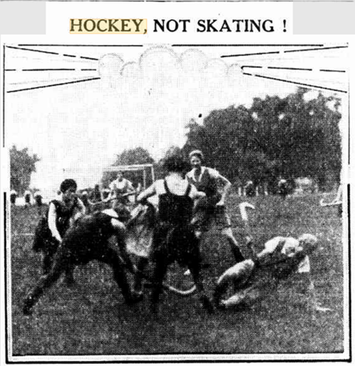
1931 Grand Final
Old Modernians 3; Boronia nil. Scorers: — Constance Flannigan 2; Mary Mather
In the 'A' Grade Old Modernians played North Cottesloe (minor premiers) Old Modernian gained the premiership in one of the best matches of the season. Both teams played fine open hockey. Strong defences prevented any scoring; until shortly before time, The North Cottesloe players, becoming over-anxious, crowded the circle. C Flanagan broke through and scored for Old Modernians. The winners combined well throughout. Jean Fitch, Marjory Bennett and Lilian Mitchell were in particularly good form; while for North Cottesloe. A. Peacock, V. Gadsdon and T. Smallpage were outstanding.
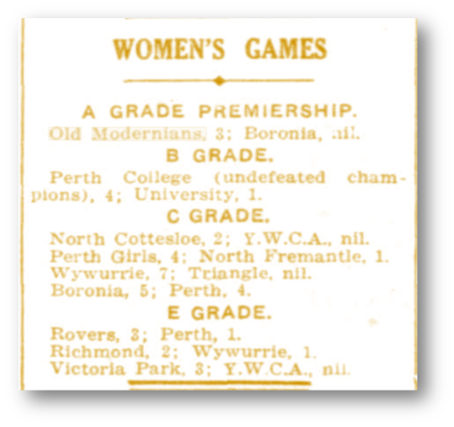
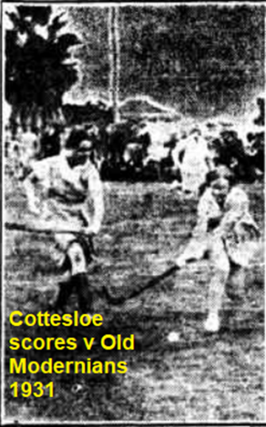
1932 - SECOND FLAG
This success carried over into 1932 when the ‘A’ team were Minor Premiers, losing only one game and having just one draw during the season, culminating in another Premiership victory. The newly promoted ‘C’ Grade team performed creditably. In this and later years the second team was often short of players but was in the fortunate position of being able to recruit girls from within the School team.
WOMEN'S ASSOCIATION.
Old Modernians Win 'A' Grade Final.
On Saturday, in the final for the 'A' Grade premiership of the Women's Hockey Association, Old Modernians proved too strong for North Cottesloe, the only team which' had defeated them, during- the season beating North Cottesloe 6-1. Half-time, 4 -nil. Goal scorers: Old Modernians: Flanagan (2), Mather (2)', Chandler and Wauchope. North Cottesloe: Brewer.
Throughout the game, Old. Modernians combined better, were quicker, on the ball, and made better use of the attack than their opponents. North Cottesloe, whose team work, was somewhat disorganised by the' absence through Illness of their centre-half, were inclined to fumble when opportunities occurred for' scoring.
1933 – A GRADE MINOR PREMIERS
In 1933, the team changed significantly as several senior members retired but the new recruits performed well and the team won their third consecutive ‘A’ Grade Premiership, defeating University.
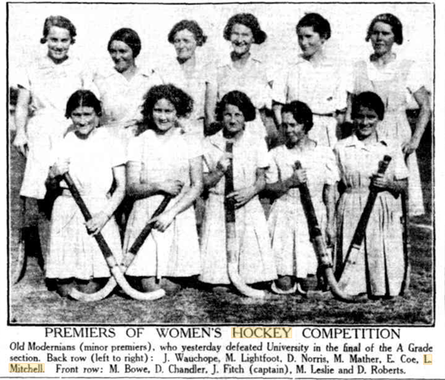
1933 Team was: Jennie Wauchope; Marion Lightfoot; Mrs Dorothy Norris: Mary Mather; Emma Coe; Lila Mitchell, Mary Bowe; Dorothea Chandler; Jean Fitch; Mary Leslie; Delys Roberts.
1934 –A GRADE ‘RUNNERS-UP’
This year marks the fourth year of the club’s existence and again both A and C Grade met with success. The First team played in the final but failed to win, thus losing for the first time the Premiership Title. Jean Fitch, Lilian Mitchell and Mary Mather represented the club in the Metropolitan team which played in Country Week, and Jean and Mary were members of the State team. The ‘A’ Grade team lost the Grand Final 4–2 to Boronia, but the ‘C’ Grade team were Premiers and were promoted to ‘A’ Reserve Grade for the first time.
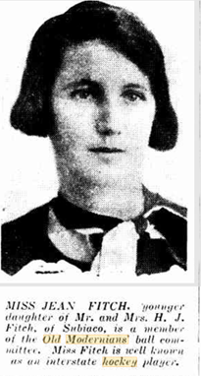
1935 –A GRADE FINALISTS AGAIN
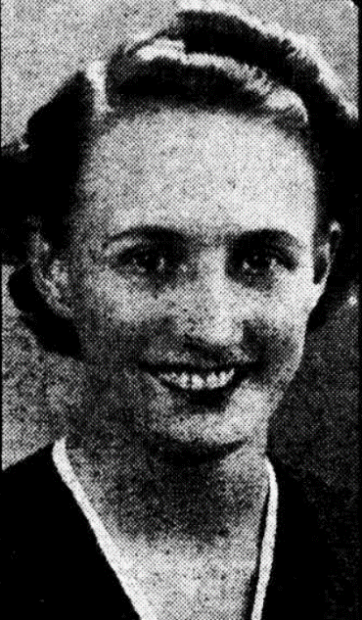
The following year the ‘A’ Grade team finished third and did not reach the Grand Final, while the ‘A’ Reserve team finished a creditable fifth in their first season in that grade. The acquisition of recent student, Queenie Lynch, proved to be a tremendous boost to the team in future seasons.
Queenie was an exceptional player who always featured in the team’s best players and immediately gained selection in State and later Australian Teams.
She had a long playing career which extended beyond the war years.

A social game between the OMHC women’s and men’s clubs was staged at the school in October, 1935, the men winning 3–1, a rare instance of interaction between the two clubs.

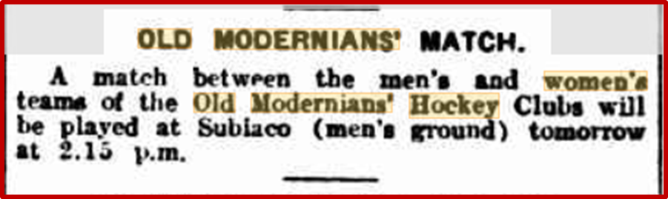
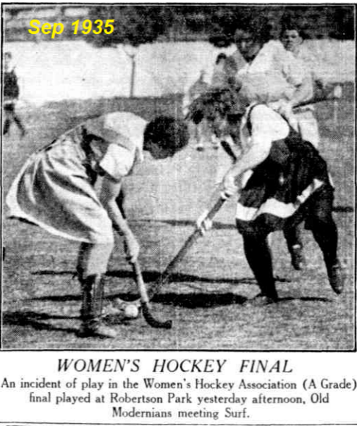
OLD MODERNIAN STATE REPRESENTATIVES

OLD MODERNIANS SELECTED FOR AUSTRALIAN BLUE RIBAND (VIRTUAL) SQUADS
1936 SEES NEW PLAYERS RECRUITED
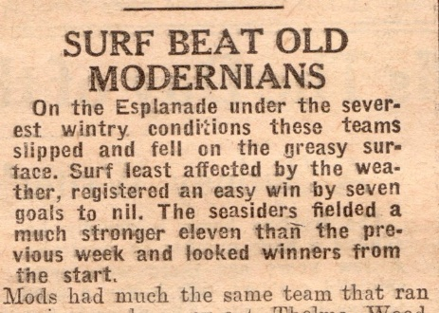
The start of the 1936 season saw the retirement of several key players; Jean Fitch, Mary Mather and Marion Lightfoot, some of these through injury. Mary Bowe was elected the new ’A’ Grade captain. In the 1937 season the team missed the ‘A’ Grade finals for the first time, and for the 1938 season Queenie Lynch was elected captain after the retirement of Mary Bowe, who was the last remaining member of the original 1931Team. Another gifted player to join the team was Dorothy Hateley who had returned from teaching in regional areas and in 1939 rapidly gained State and Australian selection. Her playing career also extended beyond the war years.
1937 MISSED FINALS FOR THE FIRST TIME

Pirates v. Old Mod. (A)
Played amidst all the discomforts of last Saturday, teeming rain and with portions of the Modern School Oval under water the Pirate team registered its second win in the A Grade by defeating "Mods" by three goals to two.
Right from the opening whistle Pirates were the superior side and at all stages looked the winners. A. marvellous exhibition of keeping by Mary Leslie the "Mods" custodian kept the score down. Modernians took the field with Q. Lynch missing, but had the services of their erstwhile star winger Jean Fitch, now Mrs Dukes who filled the inside left- position. Pirates had a re-organised forward line, Madge Ness from Narrogin being inside right while Cynthia Marsh from YWCA played in the outer position.
The hockey despite the elements and the ground was good and Pirates showed some smart combined forward movements. Mods played hard, but most of their forward rushes foundered at the sticks of Clune and Wright, a solid pair of defenders. Madge Ness opened the scoring with a nice shot. Heading another rush, Ness shot again from the angle and Nell O'Connor, giving a great display at centre half, netted the rebound making Pirates two goals up. "Mods." then troubled the scorer, Jean Bateman pushing one past Cowan. With the rain so thick you could not see the players, the second half was a repetition of the first. Pirates were the first to hit a goal, Rene Martin driving very bard past Leslie following some good play by C. Marsh on the wing. Bid Perry and Middleton were a stubborn pair of backs, but Leslie was the hero of the defence, some of her stopping being remarkable Molly Fyfe and Alma Thompson well at times, but "Mod" forwards seemed weak on the day. Just before time the "student" forwards notched another goal, Jean Bateman again being responsible after a wing dash by Fitzhardinge.
The winners had great service from all their players, their half-back' line being very effective. Most prominent were Ness, O'Connor, Clune and Wright. For Modernians, Leslie, Perry, Fyfe and Bateman battled hard. Efficient umpires were Misses B. Mengler and M. Highet.
THE TEAMS - 20 AUGUST 1937
Old Modernians "A" Grade: Leslie, Middleton, Perry, Fyfe, Baxter, Fitzhardinge, Bowe, Bateman, Lynch, Thompson and Miller. -
Old Modernian. "A" Reserve: Utley, Donegan, Dunlop, Manning, Bell, Lawson, Kretchmar, Birch, Hope, Fitzhardinge, and Middleton.
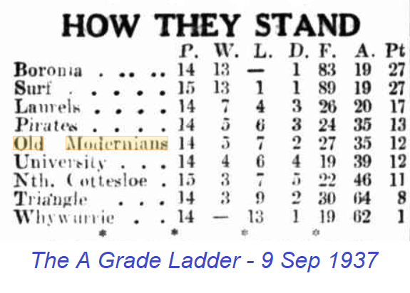
1938 CONSOLIDATION OF TWO TEAMS
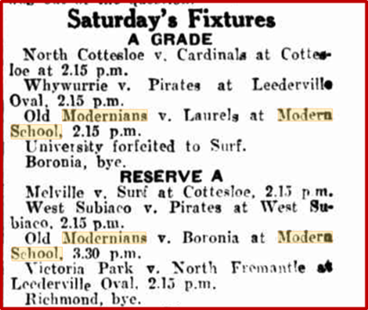
1939 STILL IN THE FINAL FOUR
PIRATES, OLD MODERNIANS IN FINAL FOUR
By winning their matches in the last set .of the second round today. Pirates and Old Modernians won their way into the final four. They now occupy third and fourth places.
WOMENS HOCKEY
After having suffered only one defeat for the season. Surf (minor premiers) yesterday defeated Old Modernians in the finals by three goals in a keen, hard-fought match.
Scoring started early when Lucy Crane found the net for Surf shortly' after the opening whistle. From the following centre bully, M. Giles swept the ball straight down to the goal and evened for Old Modernians. Surf attacked strongly for a few minutes, and from some heady combination between M. Pearce and Crane, Pearce scored a beautiful goal. A further goal for Modernians shortly before the interval by L. McArthur, following an exciting scrum at the goalmouth, brought the half-time scores to 2-all.
In the second half the quality of the play suffered somewhat by the rugged nature of the game. Through some magnificent efforts on the part of Pearce, who put in three more goals? Surfs position was secure.
Results A1 Grade (Final) Surf 5 (May Pearce 4, Lucy Crane) defeated Old Modernians 2 (M. Giles and L. McArthur).

WOMEN'S HOCKEY. State Team Selected.
The women's hockey team to represent Western Australia at the all-Australia carnival in Adelaide next month has been chosen and the team will leave for Adelaide by the Westland express on Tuesday. August 15. The carnival will start the following Saturday. A strong team has been chosen. Four members-Queenie Lynch , May Traylen, May Pearce and Lucy Crane-being included in the Australian women's hockey team which will visit Great Britain in about five weeks’ time.
The State sides is as follows:
P. Williams (Donnybrook).
J. Pearce (Surf).
P. Palmer (North Cottesloe).
J. Loftus (Geraldton).
Queenie Lynch (Old Modernians).
May Traylen (Laurels).
Dorothy Hateley (Old Modernians).
J. Barnett (Pirates).
May Pearce (Surf).
Lucy Crane (Surf).
D. Cooke (Boronia).
D Payne (Surf).
D. Simmons (Donnybrook).
The four West Australian members of the Australian team will remain in Adelaide for two or three days after the carnival to train with the rest of the team, but it is expected that they will return to Perth to spend the week-end before joining the boat at Fremantle. In England matches will be played at Bournemouth against teams representing England, Ireland, Scotland, Wales, America and South Africa. After the series the Australian side will make a tour of some of the counties and will finally play a match in Scotland. It is hoped that a week may be spent on the Continent before returning to Australia.
1940 FURTHER RECOGNITION

WOMEN'S HOCKEY. - Exhibition Match on SATURDAY.
The following Players have been chosen by the West Australian Women's Hockey Association for the exhibition match at the W.A.C.A. around on Saturday as part of the programme of the women's pageant of sport organised by the W.A. Women's Hockey Association and the Sportsmen's Organising Council for Patriotic Funds:
No. 1 Metropolitan Eleven. -Goal. B. Cowell (Pirates). Full-backs, J. Pearce [Surf). P. Palmer (North Cottesloe). Half-backs. Queenie Lynch (Old Modernians). M. Traylen (Laurels). Dorothy Hately (Old Modernians). Forwards. A. Thompson (Surf), May Pearce (Surf), A. Crane (Surf), D. Cook (Boronia). M. Payne (Surf).
No. 2 Metropolitan Eleven.--Goal J. Utley (Old Modernians). Full-backs. D. Howe (Pirates),. M. Henderson (Boronia). Half-backs. E. Kean (Surf) M. Graham (Old Modernians. MT. Stoltze (Boronia). Forwards, P. Howe (Pirates). M. Giles (Old Modernians), D. Norris (Boronia). R. Martin (Pirates). S. Johnson (Laurels).

Several matches have now been played in the final round of women's hockey and the various teams are struggling hard to gain a place in the final four. In the "A"1 grade, Surf is again on top, having been undefeated this season. Boronia follows in second place, with Old Modernians a close third.
Following is the position of teams in all grades up to July 27, 1940:
"A1" Grade.--Surf (24 points), Boronia (18), Old Modernians (15). Pirates (10), Laurels (9), North Cottesloe (8), Cardinals, nil.
"'A2."-Richmond (22), Pirates (19). 'Whywurrie (16). Wanderers (9). University (7), Boronia (6). Surf (5. 1
Reserve "'A"-Melville (22), Scots (19), Richmond (14). West Subiaco (12). Pirates (9). Victoria Park (4). Old Modernians (2).

Highlights of 1940
- Queenie Lynch and Dot Hateley again selected in the Combined Metropolitan #1 Team’
- Although Old Modernians beat Laurels by three goals to one, the game on Saturday 1 June was apparently closer than the final score indicated. Best players for Old Modernians were J. Langridge, Queenie Lynch and Dot Hately,
- In the Reserve A Grade Old Modernians forfeited to Pirates on Saturday July 20, school holidays perhaps. On the same day Surf easily defeated Old Modernians in the "A"1 Grade series of the Women's Hockey Association on Saturday, Lucy Crane scoring five of their eight goals. For Old Modernians J. Fitzhardinge (2) and J. Dukes scored.
- Progressive totals in "A"1 at August 26 were as follows: Surf (30) points, Boronia (22), Old Modernians (18), Pirates (16), Laurels (12), North Cottesloe (nil).

POST 1941
From 1941 onwards, many sporting Associations and their affiliated clubs went into recess for the duration of WW2, although some matches were likely played on an ad hoc basis. A composite team named the Secondary Schools Old Girls Hockey Team which had six members from the Old Modernians’ Club was probably an example of this.
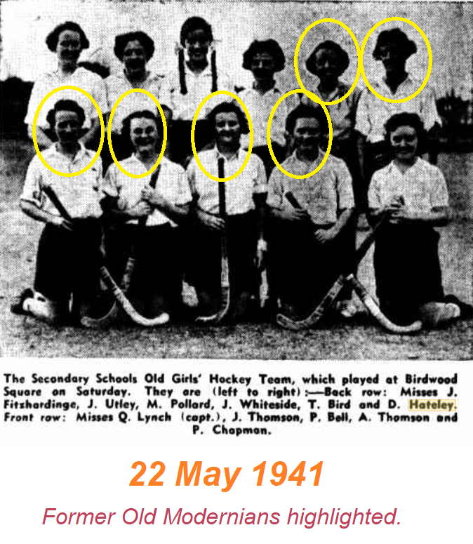
Not all clubs in recess survived to the post-war years, and a note in the November 1942 “Sphinx” magazine states:
“Owing to other demands on the players’ time, the Girls Old Modernians’ Hockey Club has now disbanded. The Club’s final act was to donate 5/14/0 (AUS pounds) to the School for the purchase of garden seats, and for this we are very grateful”.
THE FIRST FOUR YEARS

The assistance of the Old Modernians Association and Museum in compiling this history is gratefully acknowledged by the authors.
Jean Fitch was an exceptional athlete, winning several State sprint titles, and on the hockey field was a speedy and skilful left wing who first gained State selection at age 20 while still studying at Claremont Teachers College. Thereafter, she represented WA at State Carnivals until her retirement in 1936 to marry. She stood aside in 1933 and 1935, in part to allow another school teacher to be selected. She was State Captain in 1934 and gained Australian selection again that year.
A Boronia player (right) successfully tackles an Old Modernian in yesterday’s match at the Modern School ground, May 1931
The Esplanade was something like a ‘slippery dip’ for this game against Swans in 1931
Sunday Times Sun 6 Sep 1931
The West Australian Mon 22 Aug 1932
The Old Modernian 1934
The Daily News Thu 21 Jun 1934
The West Australian Fri 4 Oct 1935
The Daily News (Perth, Sat 7 Sep 1935 Page 4
Australian Hockey Records
1936
New Call and Bailey's Weekly Thu 1 Jul 1937
New Call and Bailey's Weekly Thu 1 Jul 1938
The Daily News Sat 2 Jul 1938
Mirror, Perth, Sat 29 Jul 1939
Western Mail, Perth, Thu 13 Jul 1939
Sunday Times, Perth, Sun 13 Aug 1939
The West Australian. Perth, Thu 27 Jul 1939
Queenie Lynch was subsequently forced to withdraw from the AAWHA Touring Team for financial reasons.
A rather optimistic prediction as you can see from the date. Their ship was shortly to be requisitioned for the War effort
The West Australian, Perth, Thu 11 Apr 1940

