Welcome to all of our new and returning members for 2015 season.
Modernians Hockey Club is a family focused club who believe that sport is for everyone. We hope you all have fun and success this season.
Online registration is still open, and it’s never too late. You can follow the link below and complete the process. https://memberdesq.onesporttechnology.com/1215/reg/subs.
________________________________________________________________________________________

TRAINING
- J3/4 – commences Thursday 23rd April at 4.30 pm-5.30pm (week 1 of Term 2)
- J5/6- J11/12 - commences Thursday 13th March at 4:30pm. Check the Clubroom window for locations for your teams training.
- Coaches will contact you directly regarding training, as there may be some of the senior teams training at different times.
- The Cricket Club has priority for the grounds during March so please be considerate an steer clear of the Clubrooms unless necessary.
- Don't forget your Mouthguards as they are compolsory during training.
- Minkey - commences Thursday 23rd April 4:30-5:30pm.
- Don’t worry if you do not have a stick at first training, we have equipment available for loan.

Eligible Junior members can source
financial assistance using the KidSport Program via City of Vincent
www.vincent.wa.gov.au/Services/Community_Development/Sport_Recreation/KidSport

UNIFORMS
Uniforms are available to purchase from the club rooms on Thursday nights. Including our socks.
Uniforms are compulsory for J5/6, J7/8, J9/10 and J11/12 for games.
During training sessions Jan Matthews will be available to take your uniform orders, including our ever popular ‘Mods hoodie’
We have some 2nd hand uniforms for sale, and If you have out grown your uniform we would welcome it being donated back to the Club.
Shin pads are highly recommended, as is a water bottle, for both trainings and games.
Please ensure your child’s hockey stick is size appropriate.
Hockey sticks, shin guards and socks will be available for purchase at the first training session. PLEASE LABEL ALL YOUR GEAR.

SEASON GAMES
- J3/4 - start date is yet to be confirmed but likely to be Saturday 16th May 2015 at Perry Lakes. Coaches will keep you updated.
- J5/6 - Grading Carnival is on Saturday 2015 at Yokine Reserve, attendance is compolsory. It is a full day event.
- J5/6, J7/8, J9/10, J11/12 Session starts weekend of Friday 1st May - 3rd may 2015.
- Fixtures will come available the last week of April.
- Minkies - there are no saturday games. Thursday 4.30-5.30pm
- Players must wear a mouthguard during all games.

KEEP IN TOUCH...
Web:: mo l.com

MOUTHGUARD FITTINGS

- MOUTH GUARDS - Leederville Dental Clinic will be doing custom mouthguards on Thursday 19th March between 4pm – 5.30pm at the clubrooms. Cost is $99 per mouthguard. Please email practice@leedervilledental.com.au or phone 9388 3370 to place your order and arrange an appointment time.
· Accidents can happen at anytime, as soon as you have a stick in your hands and a ball in play, your mouthguard should be in!
J3/4 Mini Nines Tournament – September 2014
In September, Mods were asked to nominate a J3/4s team to play a 9 aside game at the Perth Hockey Stadium on Saturday 20th September. The tournament was played between the 1st division women’s and 1st Divison men’s Grand Finals. Teams were nine a side, with 3 subs per team. Games were 7 ½ mins each way, utilizing normal grads size goals and played across quarter of a field. The main emphasis of the day was participation and fun!

to match".

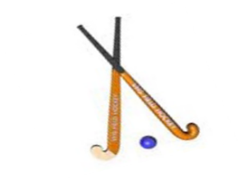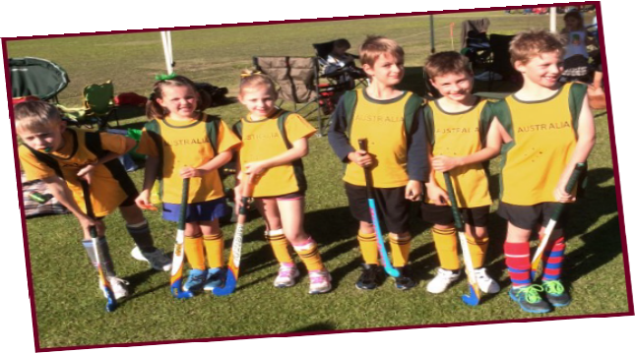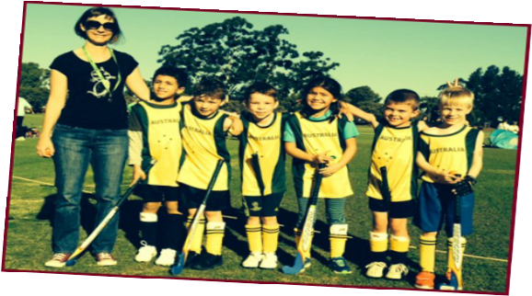

CONTACT US
Email: modsjnrhockey@gmail.com WWW: www.modernianshockey.org
Junior President - Ben Matthews 0403 347 920 ; juniorpresident@modernianshockey.org
Registrar – Jo Monaghan 0425 702 894 ; juniorregistrar@modernianshockey.org
Treasurer – Charlie Gilkes 0488 982 161 ; charlie.gilkes@watc.wa.gov.au

.

